Latest Updates
- Revised Quarantine and Isolation Protocols
Last updated: 1/19/22
Miles College has updated its protocols to follow the new Centers for Disease Control and Prevention guidelines for COVID infection and exposure. As the nature of the pandemic has changed, health guidance has changed, which can be confusing. We are providing this summary to help you understand what to do in different situations.
This communication provides information on:
  - WHAT TO DO IF YOU ARE FEELING SICK
  - WHAT TO DO IF YOU TEST POSITIVE FOR COVID
  - WHAT TO DO IF YOU ARE EXPOSED TO COVID
  - COLLEGE COVID TESTING OPTIONS
  - VACCINATION AND BOOSTER SHOTS

WHAT TO DO IF YOU ARE FEELING SICK
  - Stay home and wear a mask if you’re around others.
  - For students, don’t go to class, and let your instructors know you aren’t feeling well.
  - For employees, don’t go to work, and let your supervisor know you aren’t feeling well.
  - Contact Healthctr@miles.edu for an assessment to obtain an at-home COVID test, or you can schedule a COVID test in the community
  - Do NOT test during the College’s daily surveillance testing, which is for people who are not experiencing symptoms.
  - Until you get a negative test, act as if you’re positive (mask and quarantine from others).

WHAT TO DO IF YOU TEST POSITIVE FOR COVID
Report your positive COVID test by filling out the COVID Self-Report Form, which will automatically notify the COVID Response Team.
General guidance for people who test positive for COVID:
  - Isolate at home for at least 5 days from the onset of COVID symptoms or, if you have no symptoms, isolate from the date of your positive test.
  - You can end your isolation after 5 full days if you are fever-free for 24 hours without using a fever-reducing medication and your symptoms have resolved.
• Note: If you are a student-athlete, you will need to obtain a negative test result to participate in athletic activities.
  - Continue to wear a well-fitting mask (KN95 or N95 masks) for 5 additional days when in public or around other people, and avoid eating around others during this time.
  - If you share a living space with others, you must always remain masked around them.
  - If you are immunocompromised or have other health concerns, you should consult with your healthcare provider on your specific needs and length of isolation.
  - You will need to determine your close contacts from the 48 hours prior to the start of symptoms, or prior to your positive test if you do not have symptoms, and you may be asked to contact these individuals.
Students who test positive
  - Once we are aware of your case, a COVID Response Team nurse will connect with you to provide guidance on the next steps.
• If you test at Capital, the COVID Response Team will contact you automatically.
• If you test outside the College, including home tests, you must report your positive COVID test by filling out the COVID Self-Report Form.
  - Classes: You should notify your instructors as soon as possible to create a plan for your classwork and assignments.
  - Housing: Residential students who cannot go home to isolate should notify the COVID Response Team at Healthctr@miles.edu for assistance with housing options.
•On-campus quarantine and isolation housing is limited and cannot be guaranteed. All students should have individual plans for isolation and quarantine housing if they are exposed or have a positive COVID test.
  - Follow up: At day 5, if you have questions about your continuing symptoms, you should contact the COVID Response Team at Healthctr@miles.edu for an assessment to assist with determining your next steps.
  - If you are in College isolation housing, a housing representative will contact you at day 5 to determine your next steps and whether you can leave isolation.
  - Assistance: If you have a primary healthcare provider, that provider would have the role of your primary advisor regarding your medical condition. The COVID Response Team can assist with questions about COVID, the College’s expectations for isolation or quarantine, and with resolving COVID-related concerns.

Employees who test positive
  - Once we are aware of your case, a COVID Response Team nurse will connect with you to provide guidance on the next steps.
•If you test at Capital, the COVID Response Team will contact you automatically.
•If you test outside the College, including home tests, you must report your positive COVID test by filling out the
COVID Self-Report Form
  - Human Resources: You should coordinate with your supervisor and Human Resources regarding the need for any leave time and follow time-off procedures.
  - Follow up: At day 5, if you have questions about your continuing symptoms, you should contact the COVID Response Team at Healthctr@miles.edu for an assessment to assist with determining your next steps.
  - Assistance: If you have a primary healthcare provider, that provider would have the role of your primary advisor regarding your medical condition. The COVID Response Team can assist with questions about COVID, the College’s expectations for isolation or quarantine, and with resolving COVID-related concerns.

WHAT TO DO IF YOU ARE EXPOSED TO COVID
Notify the COVID Response Team at Healthctr@miles.edu.
People who have a significant COVID exposure (defined as being within six feet of a COVID-positive person for 15 minutes or more, or direct physical contact for any length of time) should follow the CDC guidance of:
  - If you are fully vaccinated and have received the booster shot if eligible (5 months after Pfizer and Moderna, 2 months after J&J), you do not need to quarantine. You still must mask with a KN95 or N95 mask and monitor for symptoms for 10 full days after exposure.
  - If unvaccinated or vaccinated but out of date for the booster, you will need to quarantine for at least 5 days, mask with a KN95 or N95 mask, and monitor for symptoms.

UNIVERSITY COVID TESTING OPTIONS
On-Campus for People Without Symptoms
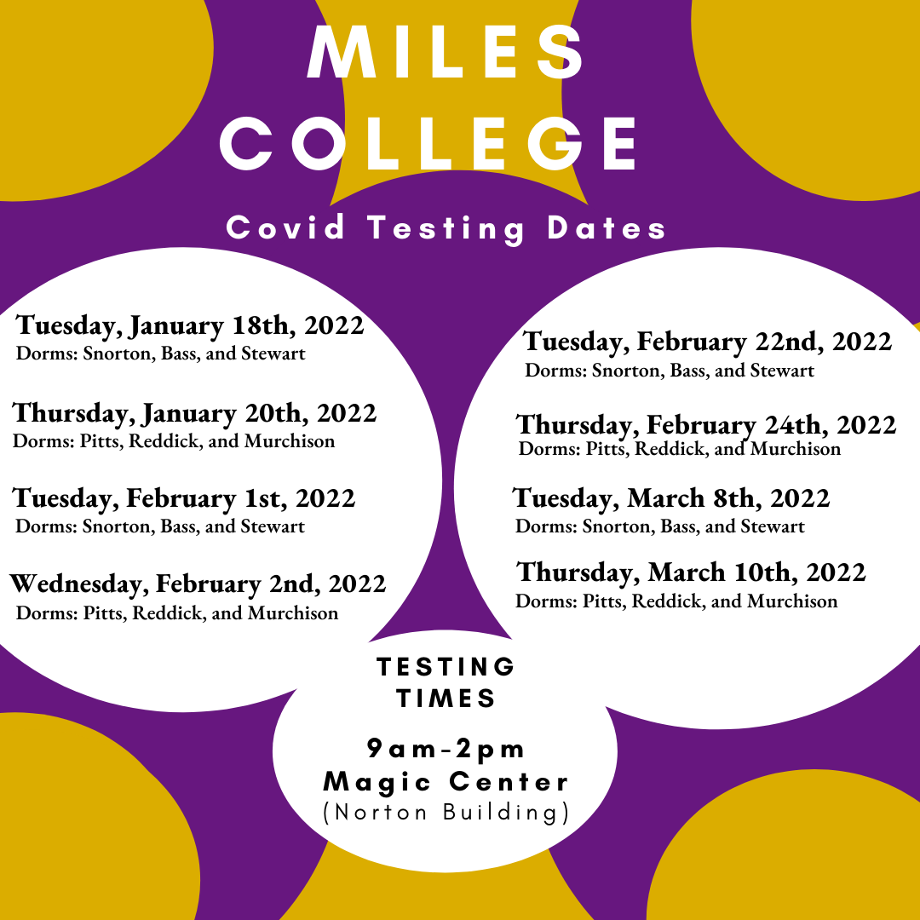

Testing Options for People With Symptoms
  - Notify Healthctr@miles.edu to arrange to pick up a home-test.
  - Schedule a COVID test in the community. You can find testing locations here

VACCINATION AND BOOSTER SHOTS
By getting a booster when you are eligible, you can reduce the chance you will have to quarantine if exposed to someone with COVID. Miles College will host several on-campus vaccination clinics throughout the semester. You can also book a vaccination appointment using the state’s website at https://dph1.adph.state.al.us/covid-19/
You are eligible for a booster 5 months after receiving both doses of an mRNA vaccine (Pfizer or Moderna) or 2 months after receiving the J & J vaccine.
Once you receive your booster dose, please update your COVID vaccination information using this link: Upload Vaccination Documentation
The COVID Response Team is here to help. We can provide guidance on following COVID protocols, assistance with COVID-related needs on campus, and assessment for testing. Contact us for assistance at Healthctr@miles.edu.
- SELF-REPORTING A POSITIVE CASE OF COVID-19
If you have received a positive result for COVID-19 and were tested off-campus, please fill out the self-reporting form.

